**IFB299 Personal Portfolio**

Group #96

Sarah Deriche, n9683542

<https://github.com/bonanaben/IFB299>

**Artefact 1** – **Data Flow Diagram**

[IFB299](https://github.com/bonanaben/IFB299)/[Sarah](https://github.com/bonanaben/IFB299/tree/master/Sarah)/Flow Diagram.png

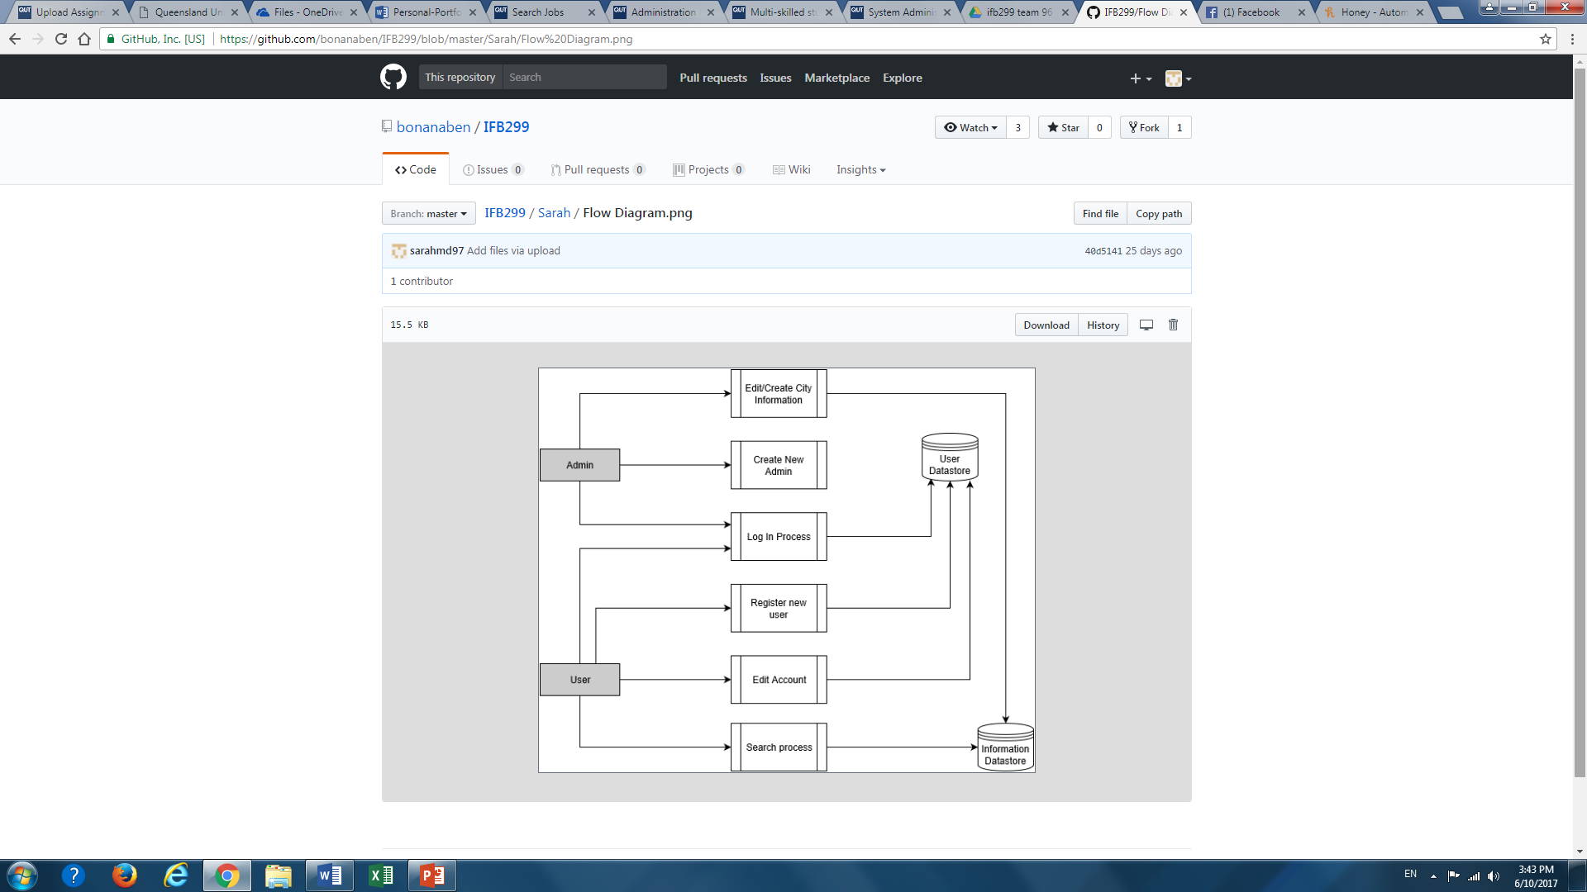

A data flow diagram is used to give both the client and developers a brief overview of the whole system process. This type of diagram shows the flow of data from external entities into the system, how data moves from a process to another, as well as the logical storage involved. The process flow displays the relationships and the data stores involved in our Smart City website and makes use of most of the user stories identified at the start of the project, and more specifically the main functionalities of the web application such as searching for results and managing accounts.

**Relevant story from sprint 1:** Story # 03, 04, 06, 07, 13.

**Artefact 2 – Architecture**

[IFB299](https://github.com/bonanaben/IFB299)/[Sarah](https://github.com/bonanaben/IFB299/tree/master/Sarah)/archJust.pdf

Designing an architecture diagram gives a deeper understanding of how the system is built and connected i.e. to create a design for the website at a system level using a type of architecture pattern that is suitable to the product and in our case we chose a 3-tier architecture due to the product being a web based application. This section consists of a brief justification to which an architecture design is chosen along with their respective logical and physical views.

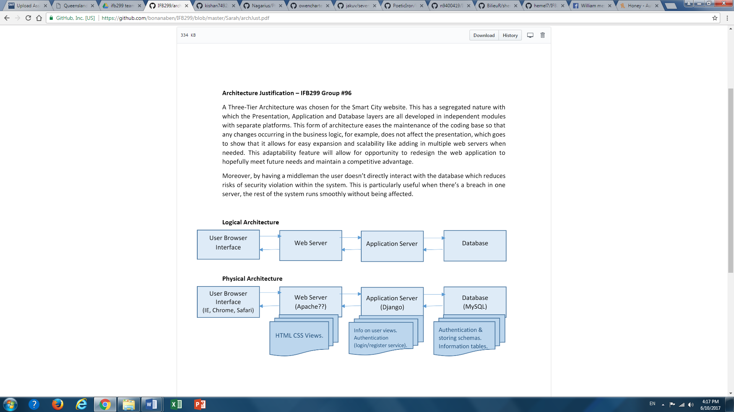

Web hosting server

Designing an architecture diagram gives a deeper understanding of how the system is built and connected i.e. to create a design for the website at a system level using a type of architecture pattern that is suitable to the product and in our case we chose a 3-tier architecture due to the product being a web based application. This section consists of a brief justification to which an architecture design is chosen along with their respective logical and physical views.

**Artefact 3** – **Component Diagram**

[IFB299](https://github.com/bonanaben/IFB299)/[Sarah](https://github.com/bonanaben/IFB299/tree/master/Sarah)/Component diaa.png

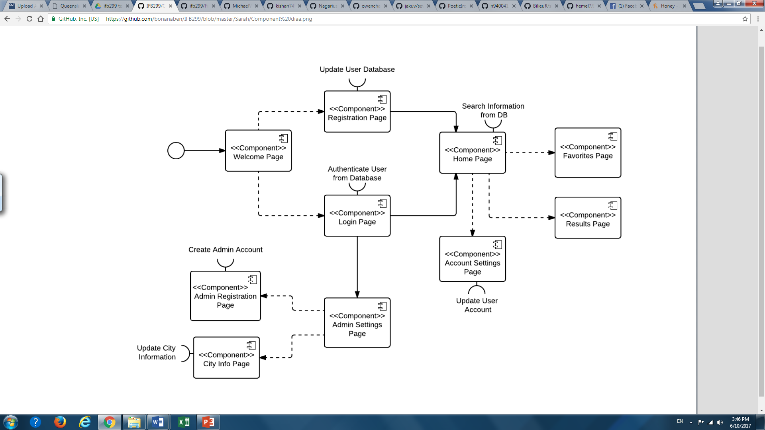

It depicts its web pages, their connections with each other and database connections.

This is a way to model some parts of our system after designing our architecture.

**Artefact 4** – **Meeting Minutes**

[IFB299](https://github.com/bonanaben/IFB299)/[Sarah](https://github.com/bonanaben/IFB299/tree/master/Sarah)/[meeting min](https://github.com/bonanaben/IFB299/tree/master/Sarah/meeting%20min)/**Meeting minutes fin.docx**

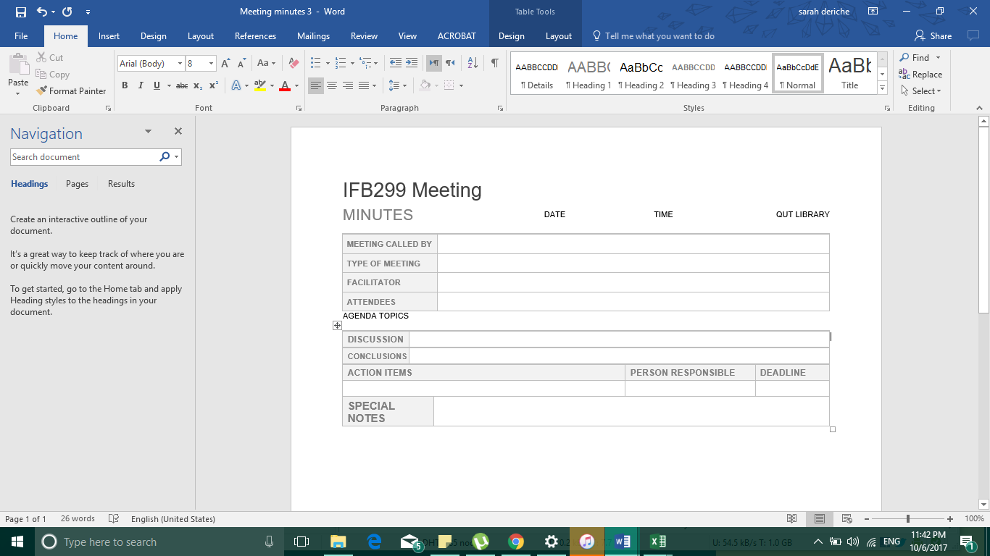

This provides a written record of what was discussed and agreed upon at a group meeting, including actions and decisions made that might have taken place, so that all members have the same recollections from the meeting and ideas about delegated tasks. Managing good meeting minutes helps to ensure everyone is aware of what needs to be achieved by what due date and go about the project efficiently.

**Artefact 5** – **Webpage design**

[IFB299](https://github.com/bonanaben/IFB299)/[Sarah](https://github.com/bonanaben/IFB299/tree/master/Sarah)/Sarah.pdf

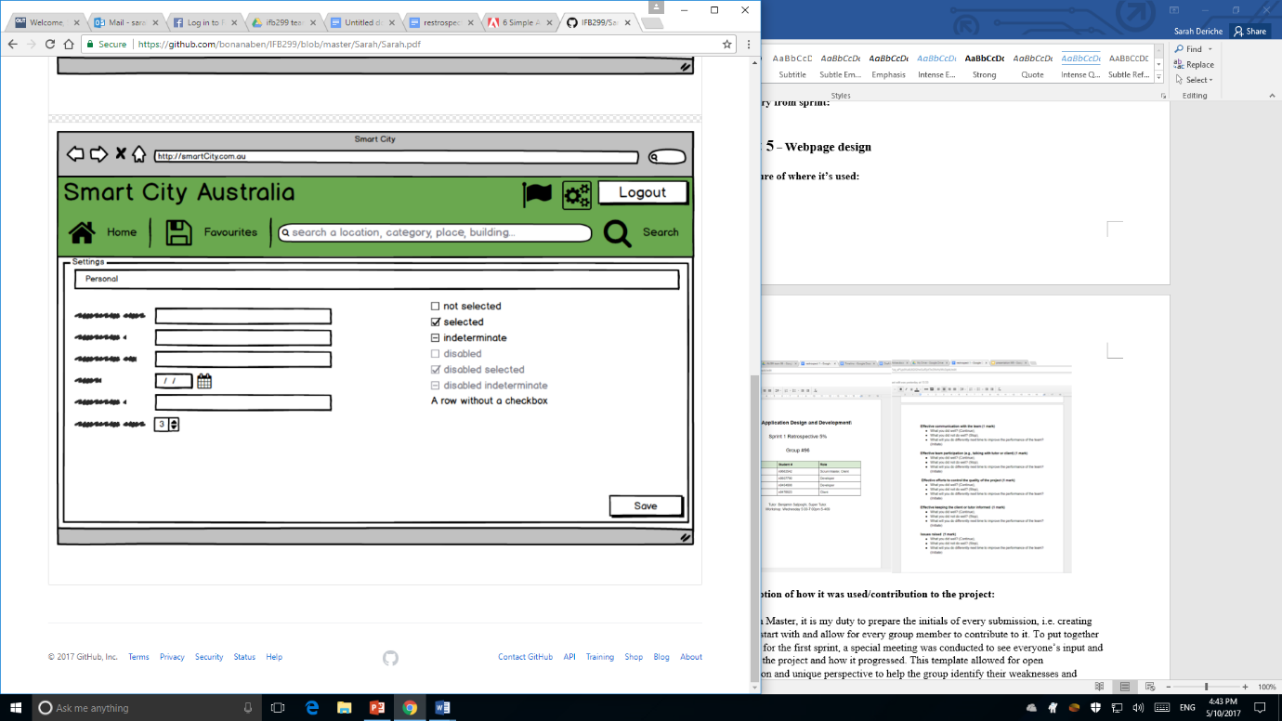 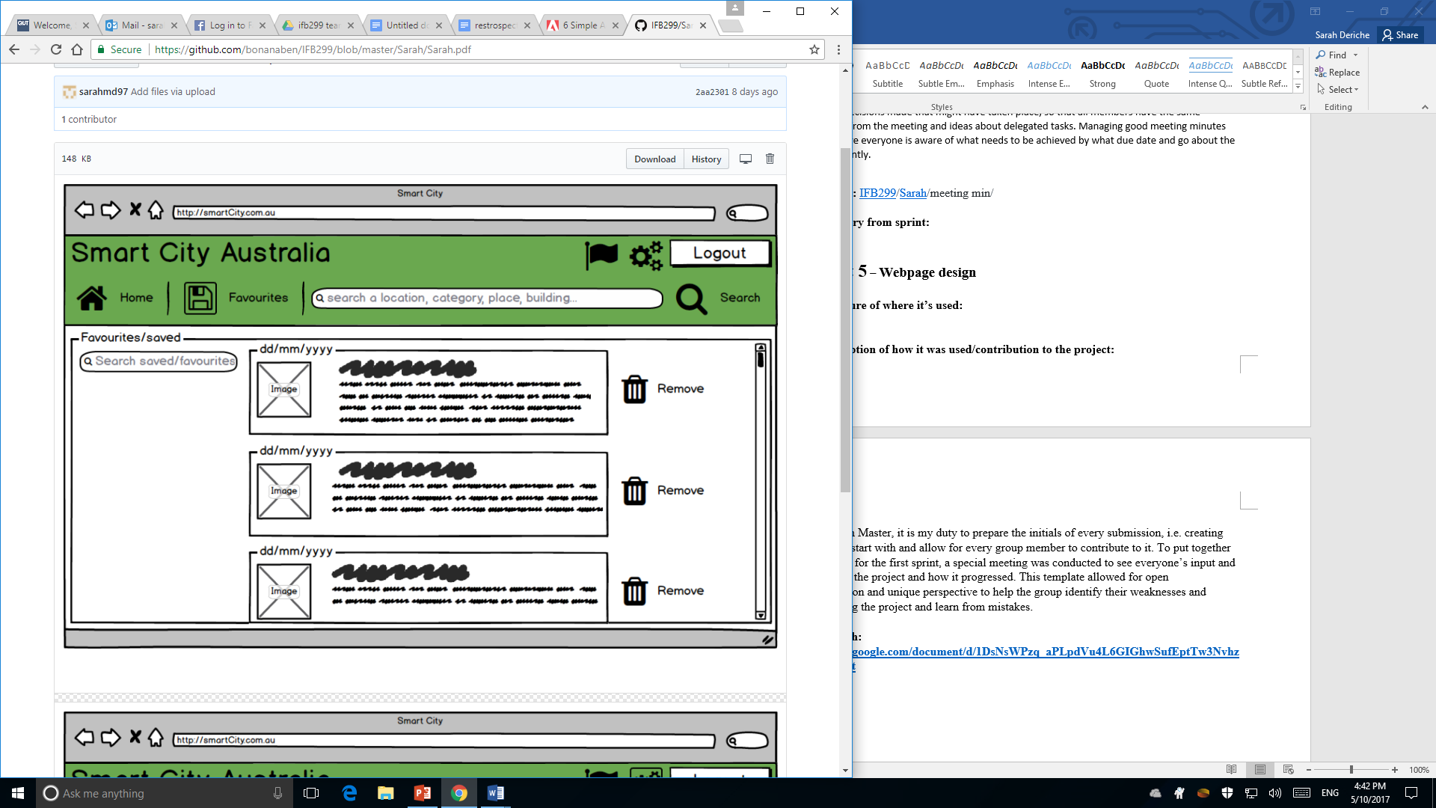

To begin the process of website designing, mock-ups needed to be created as they are essential to lay out the first look and feel of the site. These two pictures represent the visualization of the intent design, however, many changes were made after this due to its sheer simplicity and serving the purpose to only show a draft look of where icons could be placed and what features are included. This allowed us to try out various design elements, layouts, and colours before devoting to the coding section.

**Relevant story from sprint:** #15 favourites, #13 navigation bar, #2 homepage

**Artefact 6** – **Sprint 1 Retrospective and burn down chart preparation**

* <https://docs.google.com/document/d/1DsNsWPzq_aPLpdVu4L6GIGhwSufEptTw3NvhzWx3qxk/edit>
* [IFB299](https://github.com/bonanaben/IFB299)/**retrospective 1 .docx**

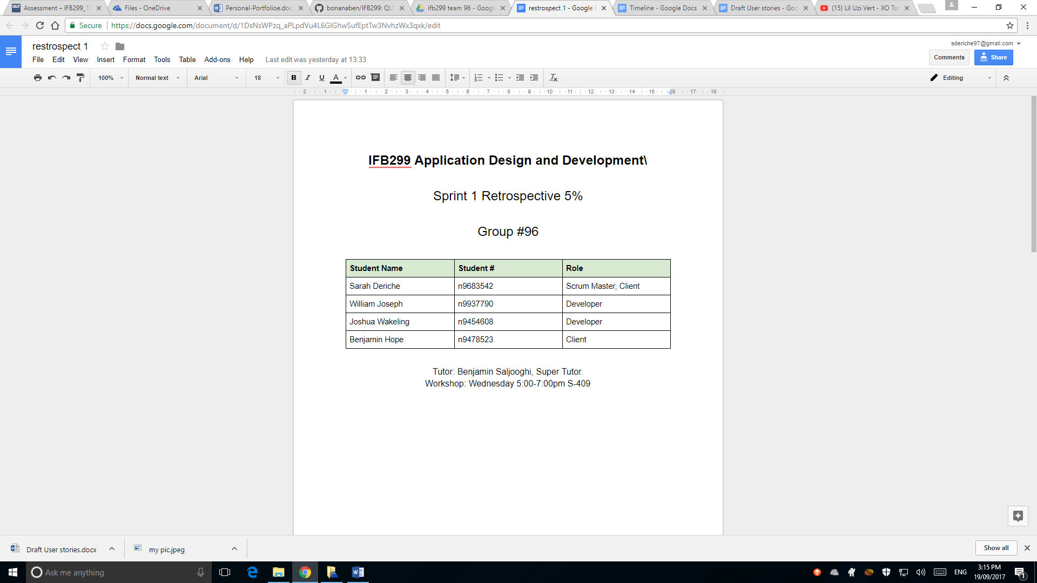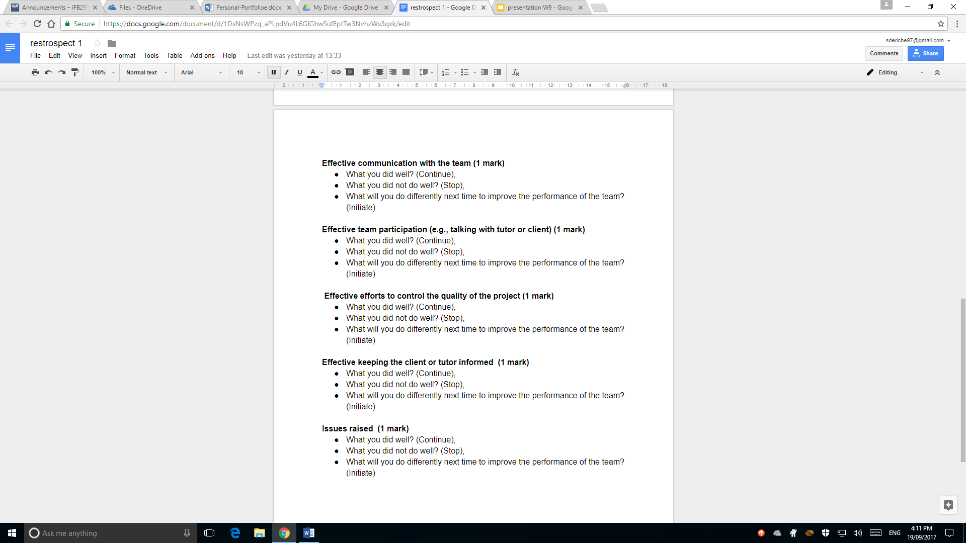

As the Scrum Master, it is my duty to prepare the initials of every submission, i.e. creating templates to start with and allow for every group member to contribute to it. To put together retrospective for the first sprint, a special meeting was conducted to see everyone’s input and their view of the project and how it progressed. This template format allowed for open discussion and unique perspective on each part to help the group identify their weaknesses and strength along the project and learn from mistakes.

[**IFB299**](https://github.com/bonanaben/IFB299)/**burndown 1.xlsx**

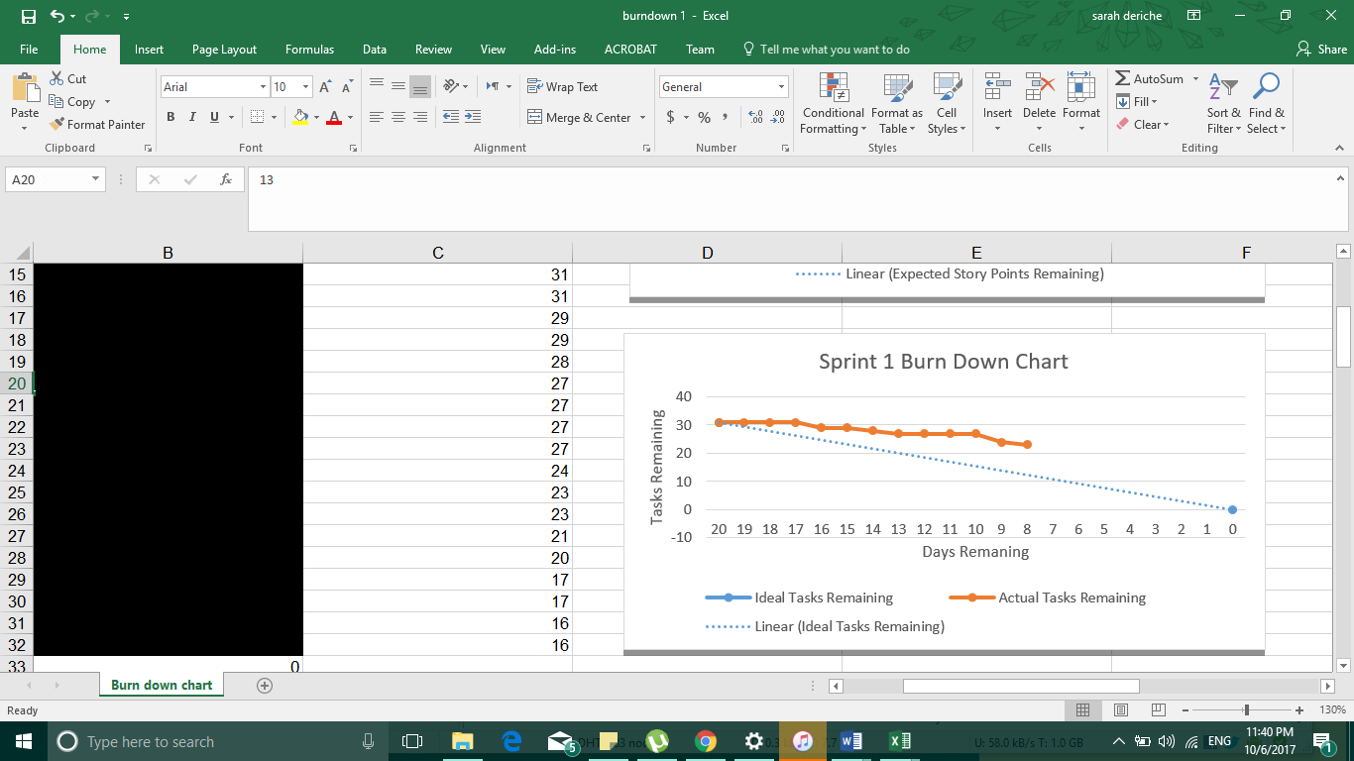

The **first sprint burndown chart** displays the project progress for each release. This contributes significantly as the team can see how much work was done and how much more needs to be done to deliver the project on time with its quality. Tracking the ideal number of tasks that remain against the actual number of tasks remaining. This helps show the amount of work thats needed to be done to complete the sprint on time. Unfortunately, the team did not manage to live up to the expectation of what we hoped for at the beginning of the project, which means some tasks will be pushed to the second sprint.